Name _______________________________
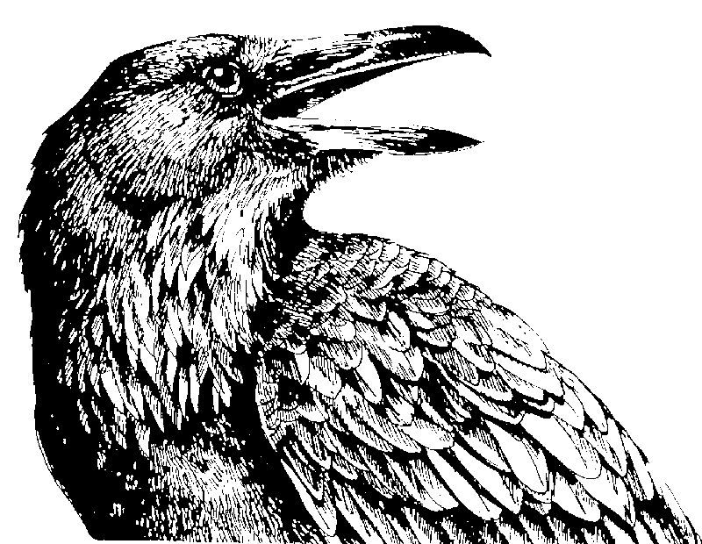
SOURCE ANALYSIS TEMPLATE
Quoth the raven “nevermore”

Article Title:

Author:

Source Info (Publication, Date):

Evaluate using RAVEN framework:
R

A

V

E

N

Reputation
What do you know about the reputation of the author, the sources, and/or the publication? Do they have a reputation for reliability? Are they in a position of authority?

Ability to Observe
Is the author in a position that allows access to reliable evidence? If the article is about an event, did the author actually observe the event?

Vested Interest
Does the author have a personal stake in the topic or event? Would the author gain anything by lying? Would the author gain anything by telling the truth?

Expertise
Does the author have specialized knowledge on the topic or event? Is the author considered an expert in the field? Does the evidence come from a source that has expertise on the topic or event?

Neutrality
Is the author neutral about the issue or is bias evident? Is the source of the evidence neutral or biased?

